**TECHNICAL REPORT**

**TRENDS IN CRIME FATALITIES AND INJURIES IN AFRICA (1974-2020)**

**1. Introduction**

This report analyzes crime patterns across West African countries using a dataset comprising various types of criminal incidents involving known perpetrator groups such as Boko Haram, Fulani extremists, and separatist factions. The region faces a complex web of security challenges including terrorism, smuggling, and human trafficking.

The insights from this data analytics project will be useful for stakeholders to identify key crimes in their localities, perpetrators of the crimes include their operations modalities, targeted groups, fatalities and injuries that occurred and the economic effect of crime to nation building and investment.

**Objective of the analysis**

The objective of this analysis is to identify trends and hotspots, with the goal of supporting security policy decisions, strengthening justice systems, and enhancing community resilience.

The analysis would also help to identify and mobilize resources to high-risk areas in view to combating crimes and insecurities.

**2. Data Overview**

The dataset is structured in rows (countries) and columns (variables such as city, weapon type, and attack details). It narrates the scope, scale, and impact of crimes within West Africa.

**Pre-Analysis Framework**:

This helps divide the data to be used for this analysis into two types; Independent and Dependent variables.

* Independent Variables: Country, City, Target Type, Perpetrator Group
* Dependent Variables: Fatalities, Injuries, Weapon type.

Data Origin: The data significantly belong to the National Criminal divisions, State security services and crimes prevention and response entities in the west Africa States.

Stakeholders: National Criminal Division, The National Governments, State and District levels Government and private security firms. Military, Police, etc.

Value Proposition: For these stakeholders, their value proposition as it relates to this dataset set and all the insights form the analysis would be a reduction in crime, implementation of intervention that reduces crime to a neglectable number and low the fatalities and injuries from crime.

**Pre-Analysis Questions**

There are several questions and potential analysis from this dataset based on the data splitting into dependent and independent variables, the key stakeholders and what value proposition will be for them.

* What are the total fatalities recorded?
* What are the total Injuries from the criminal elements?
* What year of years had the highest injuries rate?
* What year accounted for the highest death/Fatalities rate?
* Which cities recorded the most fatalities and injuries?
* What was the weapon of choice by the preparators?
* Which demographics were the most targeted by the crime elements?
* Who were the Most dangerous criminal elements
* Which countries reported the most fatalities?

**In-Analysis Findings**

* It was observed that the year 2014 top the chart for the highest fatality year with a total fatality of 8,581
* There was a rise in the fatality rate from 1992 to 2014 (with a peak in 2014). However, there was a declined rate from 2015 to 2017.
* There was also indication of the fatality rate fluctuating between year 2018 to 2020.
* 2015 was a peak year for injuries sustained from crime, with a score of 3869 injuries.
* The close nature of 2014 for highest fatalities and 2015 for peak in injuries, indicate a strong surge in criminal activities for both years.
* Low fatality rates for year proceeding 2014, might provide clue to intervention that could help reduced fatalities from crime going forward.
* Nigeria recorded the highest fatality of 29,093 deaths; this is over 70% of the entire death during the period of this analysis.
* Not surprisingly, Nigeria with the highest fatalities also had the highest proportion of injury rate (12,638) with Chad at a distance second position (1,867)
* In Nigeria as observed from this analysis, Maiduguri top the charts for fatality and injuries (2,380 death & 745 injuries). The city happens to be in the Northern region of Nigeria where insurgent activities started and have spread to other places.
* It was observed that private citizens and their property were the demographics at the forefront of targeted demographics.
* Military, Government Police and Businesses were the targeted demographics in that order.
* Armed Assaults fatalities amounted to 15,270 (or 42.09% of total fatalities) and Bombing and Explosion (26.53%) were the two main weapons deployed by these criminal elements
* It was observed that some unknown locations also had high fatality and injuries figures (1209 deaths and 436).
* There were no indications of the strategies being deployed by Governments in detecting and preventing these crimes.
* Boko Haram accounts for the highest number of fatalities (22,930) and closely followed by Fulani Extremists with a score of 3990.

**3. Post-Analysis Insights/Observations**

Detailed yearly and city-by-city insights confirmed Nigeria as the focal point of crime-related fatalities. Benin recorded the lowest crime indicators, suggesting effective measures that could be modeled elsewhere.

**Country**

BENIN

* Had the lowest fatality by year with just a total of 2 fatality in 2019 & 2020.
* Injury rate for this country was 9 which was also the lowest.
* Cotonou has the highest injuries and target type with a score of 4 and 5 respectively
* Tanguieta district (1) and keremou (1) were the only cities with a recorded fatality
* The most only targeted Demographics in this country was the police with 6 attacks.
* Armed assault was the most used weapon in this country covering 40% of all the crime committed.
* Key perpetrators were Muslim extremists (suspected) and another unknown group both resulted in the 2 deaths recorded.
* Peak injury year were 2007 (4), 1994 (3), 1992 (1) & 2020 (1). There were no injuries recorded from crime in the year 1995, 1996 and 2019.

NIGERIA

* The country injuries rate for the analysis was 12,638 resulting from crime.
* Top fatality years for this country were 2014 (7775), 2015 (5567), 2018 (2577), 2016 (2174), 2020 (2102) & 2013 (2015). While 2006 (254), 2009 (316) & 2011 (447) were the lowest fatality years.
* All the demographics were targeted by the criminal elements with private citizen & property (2559) was the most targeted. Others were military (465) Government (General) (427), police (333) Business (333) A total of 4117, demographics were targeted.
* Armed Assault top the chart for the most used weapons at 43.34% followed by bombing/ explosion (26.56%) Armed Assault, facility/infrastructure Attack (18.81%) AND Hostage taking (kidnapping) (11.29%) for Nigeria.
* Nigeria had a fatality score of 29093 for the period analyzed.
* The key perpetrators of crime in Nigeria were Boko Haram (18,205) and Fulani extremists (3987). However, there were crimes committed where the perpetrators were unknown or some groups named as suspects. Unknown perpetrators (2459), Boko Haram (suspected) (2375) and Fulani extremists (suspected) (818).
* The peak injury year for Nigeria were 2015 (2863), 2014 (2283) & 2016 (1167) while the lowest were 2010 (191) and 1999 (209).
* The peak injury year analysis showed a constant rise fluctuation in the line graph in injuries from 1999-2012, with a dip in 2013 & a significance rise from 2013- 2015. THE INJURYNUMBER STARTED DROPPING AGAIN FROM 2015-2020.
* The cities with the worst crime in Nigeria were Maiduguri (fatalities – 2380, injuries- 745 & number of targets – 488) while Kano (744, 644 & 130) Konduga (642, 219 & 36) & unknown location (738, 353 & 225)
* Total recorded fatalities – 36,256 & 2014 top at the year with most fatalities (8581)

CAMEROON

* Top fatality year for this country was 2015 (931). Others were 2014 (789) and 2019 (318).
* The fatality took a big upward jump from 2013 to 2015 & a downward decrease in mortality from 2016 to 2020.
* The country had a total injury from crime as 1642.
* Most targeted Demographics were private citizens & property (332), Military (109), Government (87), police (69) & Educational institutions (69).
* Total of recorded fatalities from crime during this period was 3186, with Boko Haram (2509) the key perpetrator followed by separatists (272), Unknown (173) & Boko Haram (suspected)-59 & separatists suspected- 30.
* With regards to the peak injury year, 2015 (463) was the highest. However, there was a sharp rise from 2014(20) - 2015 (463) and after a stable downward trend from 2015 to 2020.
* Fotokol (fatalities -485, injuries -48 & Target type -17) was the top cities by crime outcomes.
* Most used weapons was Hostage taking (kidnapping) with a 33.18% contribution. Armed Assault contributed 27.91% of the weapons used by the perpetrators of these crimes.

CHAD

* Country injuries rate – 1867
* Fatality trend report shows 2015 (306) as the worse hit year.
* 2016 (22), 1991 (40) & 2017 (62).
* Top cities based on crime activities and their outcome was N’Djamena (fatalities -265, injuries-1217 & targeted type -15)
* The country had a total of 1664 fatalities during the period analyzed.
* The pattern of most targeted demographics was same as seen in Nigeria & Cameroon. Private Citizens & property were the highest (47), then Military (39). Others business, Military, private citizen & Government were targeted 5 times each.
* Book Haram (867) and Rebels (162) were the key perpetrators of crimes in this country.
* Peak injury trends show the highest injury year as 2008 (1011), followed by 2015 (427) & 2007(138)

GHANA

* Country’s injuries rate -35
* Fatalities trend report shows 1994 (13) as the top fatality year from crime
* Unknown (fatality -9, injury -6 & targeted -6) was the city with the highest crime outcomes.
* Most used weapons by the perpetrators were bombing/ explosion (35.71%). Armed Assault (25%) & Assassination (17.86)
* Most targeted demographics were private citizen & property (13), Journalists & media (7), police (3) & Religious organizations (3)
* Total fatalities in this country from crime was 27
* The key perpetrators were unknown (20) and Fulani extremists (3)
* 2020 (12) was the year with the most injuries from crime.

NIGER

* Country’s injuries rate -751
* Total fatalities -2284
* 2015 (666), 2019 (364) and 2020 (379) were the top fatalities years.
* The highest cities based on crime outcomes was Bosso (F-284, injury -127 & targets – 13).
* Injury peak years were 2016 (143), 2020 (124) & 2015 (116).
* Key perpetrator Boko Haram (349) & Islamic state in Greater Sahara (ISGS) (249)

CITY

**Maiduguri**

This City in Nigeria had the highest causes of fatalities with 2380 deaths recorded. The number of injuries and number of target types were 1745 and 488 respectively.

The three top perpetrators of crime in this city were Boko Haram (1639), Boko Haram (Suspected) (676) and Unknown (65).

Private Citizens & Property (149). Military (47) and Government (47) were the most targeted demographics.

The year 2015 with 611 fatalities and 669 injuries, rank top as the worse hit year based on crime outcome.

1745 was the country injuries rate attributed to this City.

Bombing /Explosion at 52.19% and Armed Assault at 33.72% were the most utilized weapons for crime in this city.

**Kano**

Kano contributed 744 injuries to the country injuries rate.

The highest fatalities from this city were reported in 2012 with a fatality of 288 and peak injury year was 2014, with a total of 373 injuries.

The total fatalities for this city were 644 and injuries was 744.

Unlike, the trend noticed with targeted demographics, this city has Business (32), Religious Figures/Institutions (32), Police (16) and Government (15) has targeted groups.

With fatalities of 435 for Boko Haram and 153 for Boko Haram (Suspected), these two perpetrators were top rank responsible groups for crimes in this city.

Bombing/Explosion at 41.60% and Armed Assault at 36.80% were the most utilized weapons types by the key perpetrator of crimes.

**Unknown**

Crimes reported with no specific city identified were group as unknown. However, below are the contribution of these unknown cities.

Crimes committed in location termed as unknown resulted in 353 injuries in Nigeria, 38 in Cameroon and 32 in Niger.

2015 with 220 fatalities and 1999 with 208 injuries with the top year from these crimes’ outcomes in this city

A total of 1209 fatalities and 436 injuries were attributed to unknown cities

Boko Haram top as the perpetrator of crime in these locations with 545 fatalities.

Armed Assault (32.48%), Hostage taking (Kidnapping) (29.06%) and Bombing/Explosion (26.07%) were the top utilized weapons for crimes in these cities.

**Konduga**

This city is location in Nigeria with total fatalities of 642 deaths

Key crime perpetrator was Boko Haram with 579 fatalities

With this number of fatalities, it was not surprising that Bombing/Explosion at 44.12% and Armed Assaults at 38.24% were the most used weapons.

**Damboa**

Another city in Niger that recorded 506 fatalities, 2014 was the top rank year for fatalities with 320 deaths. 2020 was the peak year for injuries with 58 injuries.

Armed Assault was the most used weapon with 83.33% utilization.

Key preparators was Boko Haram with a total of 465 deaths.

**Fotokol**

This city is located in Cameroon and has a total fatality of 485 deaths, 2015 as top fatalities and injuries year with 288 deaths and 40 injuries.

Boko Haram was the key perpetrator of crime and utilized bombing/Explosion (47.06%) and Armed Assault (23.53%).

**4. Data Visualization Insights**

Key charts and dashboards visualized:

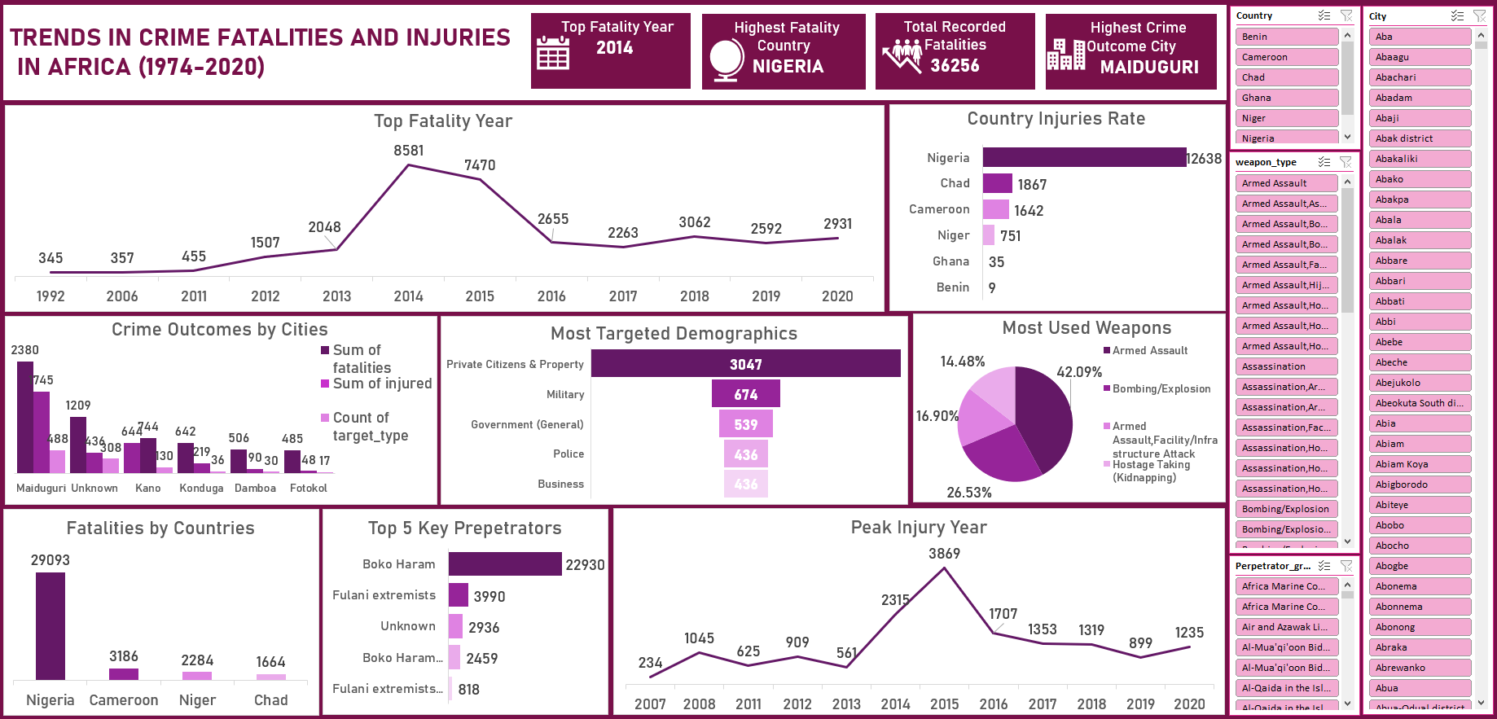

**Country Injuries Rate**

This bar chart shows the injuries rate for 6 analyzed countries, with Nigeria topping the chart and recorded a total of 12,638 injuries

**Top 5 Key perpetrator groups**

This bar chart indicates that among the identified key perpetrators of crime, Boko Haram with 22,930 committed fatalities was the worse of all the groups

**Fatality trends analysis**

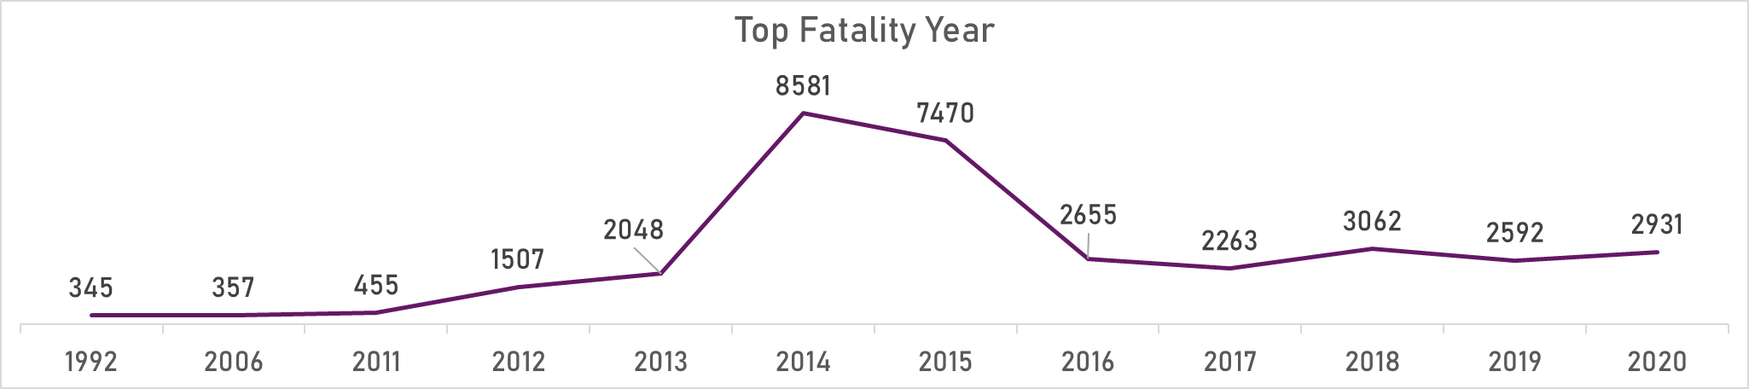

This line graph shows the total fatalities over the number of years. It enables a trend analysis of the reported fatalities for each year. 2014 with a total of 8581 fatalities top as the year with the highest crime fatalities.

**Most Used Weapons**

The pie chart denotes the contribution of the weapons used for crime in the recorded fatalities. With Armed Assault at 42.09% (15,260 fatalities).

**Fatalities by Countries**

This column chart shows the fatalities distribution by countries with Nigeria total of 29093 fatalities topping this chart.

**Targeted Demographics**

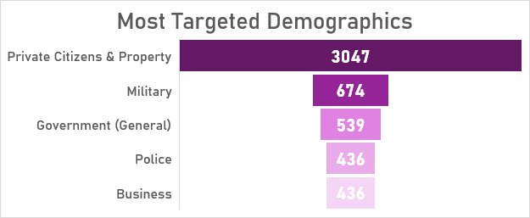

The funnel chart indicates the most targeted demographics based on the fatalities recorded. Private Citizen and Property with 3047 fatalities was the most targeted demographics.

**Peak Injury Year**

This line graph shows the trend of injury recorded from criminal elements. 2015 with an injury number of 3869 was the peak year for injuries.

**Crime Outcomes by Cities**

This cluster column chart clearly provides a comparison of crime outcomes by cities with Maiduguri with 2380 fatalities; 745 injuries and 488 targeted crimes is the top city by crime outcomes.

5. **Recommendations**

A. **Security Enhancement**

* Boost funding for security agencies for training and equipment.
* Strengthen intelligence gathering (drones, informants, cyber tools).
* Increase security force personnel to address understaffing.
* Establish military barracks in high-crime zones like Maiduguri.
* Monitor and regulate border regions with advanced surveillance systems.

B. **Governance and Inter-Agency Collaboration**

* Encourage synergy between police, military, DSS, and other agencies.
* Enforce strict accountability to tackle corruption in the security sector.
* Speed up judicial proceedings and enhance witness protection.

**C. Community Engagement and Education**

* Launch community policing programs.
* Empower local vigilante and neighborhood watch groups.
* Use religious/traditional leaders to mediate and prevent conflict.
* Promote inter-ethnic/religious dialogue to curb extremism.

**D. Socioeconomic Development**

* Expand access to education, especially in crime-prone northern regions.
* Invest in vocational training and job creation for youth.
* Develop entrepreneurship and microfinance support programs.
* Address poverty as a root cause of crime.

**E.** **Technological Solutions**

* Use AI and big data analytics to forecast crime patterns.
* Deploy citywide CCTV surveillance and monitoring.
* Launch anonymous mobile reporting platforms for crime tips.

The analysis provided insights that local content and actors are central to crime in Africa, then locally driven and individualized country solutions are indeed paramount for effective crime prevention and reduction. Some of the local solutions and recommendations are:

1. Strengthening Community policing and local Law enforcement: There is need for governments or key stakeholders to fight against crime in the ways below.

* Build Trust and Collaboration-foster a strong partnership between the polices and local communities through regular touch base meeting, quick response, sharing of intelligence, joint patrol and problem-solving initiatives.
* Recruitment and training of local officers-Community base and grown individuals could be identified, trained and deployed to such communities to serve. This could help build trust with the communities, understanding and cultural sensitivity
* Community Based Intelligence Gathering-Establish safe and anonymous means for communities’ members to share information about crimes and potential threat. The creation of neighborhood watch programs and identification of trusted community leaders could help strengthen this information gathering.
* Local Security Initiatives-Create local security outfits to support the work of police, conduct prompt patrol and quickly response to crime. Groups like community vigilantes are relevant in this strategy.

1. Addressing Socio-economical Drivers of local crime:

* Youth Empowerment programs- Established and well managed. These drivers might provide education, vocational training, entrepreneurship opportunities and business mentorship programs.
* Poverty Reduction Strategies- Government should invest in local economic developments that that help improve lives of those at the communities’ levels. Setting up of small business, supporting local agriculture and skill development
* Create mechanism for conflict resolutions -Support communities to resolve their conflict before it turn in them taking laws into their hands and committing crime.
* Address land and resources control management-Resolve all land ownership and environmental issues that could result in fights leading to increased fatality.

1. Enhancing Local Governance and Accountability

* Strengthening local institution to play an active more role in crime prevention a d control.
* Promote transparency and Accountability-Ensure all local law enforcement bodies are transparent in their operations.
* Invest in education and awareness strategies through integration of crime awareness and prevention processes into school curricula.

1. Deployment of innovative technological system to identify and prevent crime. Governments in Africa should work towards investing in innovative technological system to identify and prevent crime in community, the use of CCTV and drones for surveillance and monitoring should be encouraged.
2. Governments should improve crime fighting coordination among Africa Countries, this will help foster stronger relationship and drive home the common goal of reducing and preventing crimes.

**6. Conclusions.**

Addressing the trends of crime and all its consequences in Africa requires a strategic mix of enhanced security operations, judicial reforms, socioeconomic investment, improved coordination community engagement and involvement. Focusing on root causes like unemployment, poor education, and systemic corruption is key to building long-term safety and prosperity in the region. Implementing the recommendation from this project will go along way to solving this menace of crime fatalities and injuries in Africa.

REFERENCES

Dataset Source: Kaggle - Crime in West Africa Dataset